Minutes for Liaison Meeting 1/23

Slides:

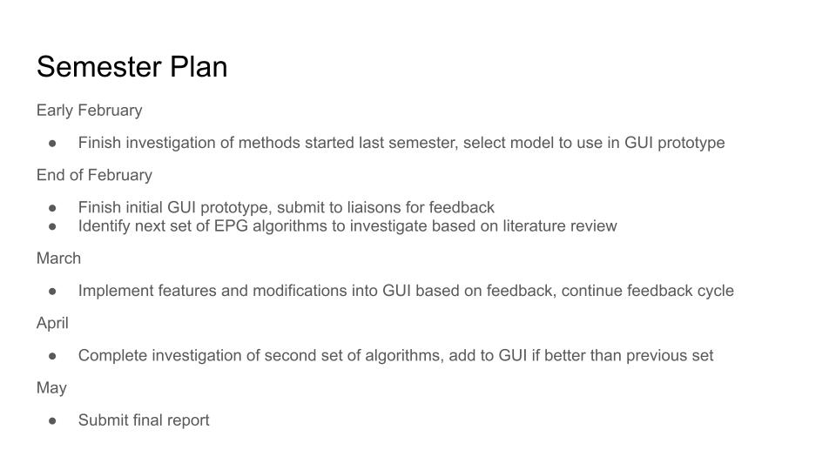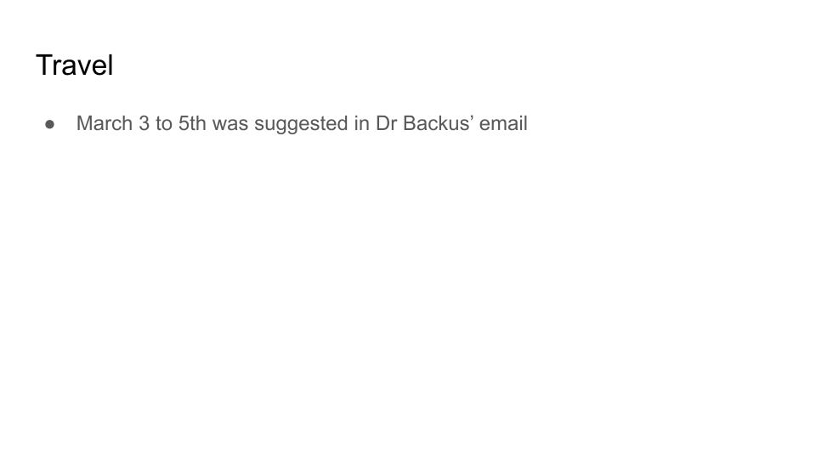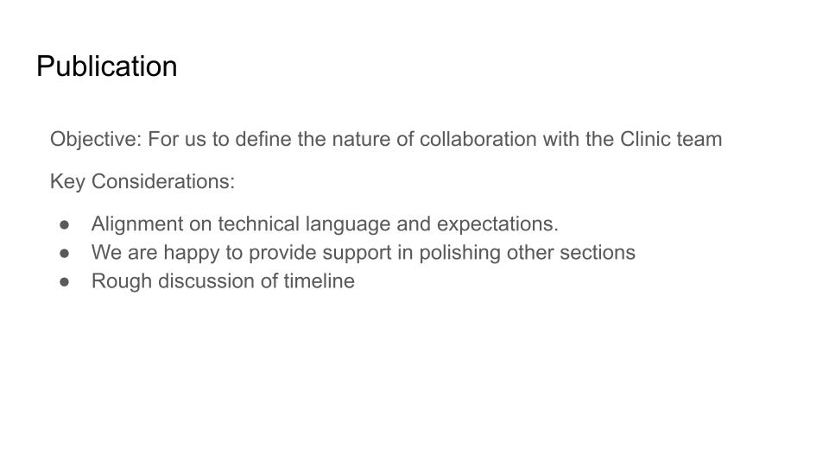

* Brief summary of plans detailed by Zach
  + Early February:
    - Finish model investigation, select which will go into the final product prototype
  + End of February:
    - Finish initial GUI prototype, submit to liaisons for feedback
    - Identify next set of EPG algorithms to investigate based on literature review
  + March:
    - Implement features/changes into GUI based on feedback, iterate to end of semester
  + April:
    - Our feature freeze (April 11) and code freeze (April 22) are this month, and we will need to stop work on code
    - Complete second ML investigation phase, add to GUI if better than previous set
  + May
    - Submit final report (May 9)
  + Dr. Reif: If we are going forward with the manuscript, that would provide a significant part of our final report, so we would be killing two birds with one stone.
* Travel discussion led by Lillian
  + Location?
    - We thought that we had planned to just go to Parlier
    - Dr. Backus has:
      * Parlier March 5-7
      * Auburn in April?
        + This would be too late for us to make any changes
    - Dr. Reif: what are the goals for the visit?
      * Seeing the research lab is a goal
      * We can use the visit to hammer out publication details
    - Zach:
      * For scheduling and location, we are open to whatever works for the liaisons
  + Scheduling
    - Dr. Reif: Early March does not look good
      * If we choose this week, Dr. Cooper would be there and Dr. Reif would remote in, but this is not ideal
    - Dr. Reif is going to be in Parlier for the engineering meeting on March 6
    - Proposed second week of March
      * Dr. Reif would only be able to do the week of March 17, which is our Spring Break
    - **We are committing to go to Parlier on March 3-5, unless the engineering team’s plans conflict**
* Publication conversation led by Devanshi and Milo
  + Define the nature of collaboration
    - Dr. Reif: first step is to find a publication to ‘emulate’
    - Dr. Cooper: Not everybody has to be a co-author, but Dr. Cooper hopes at least a few will be interested!
      * Most articles want to present the tool. We don’t want to do that
      * Confusion from mid-year report: What models have we actually investigated?
      * Happy to take the lead with writing this up, with input from us
        + Needs tables, data, technical guidance, etc.
        + Help from us would be heavily editing, making sure Dr. Cooper is talking about ML appropriately
    - Devanshi reaffirms our interest in publication
    - The number differences in the mid-year report are because we have not finished investigating certain models, or because some of the investigated subjects are not exactly models
    - Dr. Reif: maybe we just select a lower number of techniques that we have spent the most time on to describe
  + We don’t need a fully finalized version of the paper by the end of the semester
  + Dr. Backus: Can we add a critique of previously published approaches?
    - Zach: the only critique we can provide will be based on the models’ performance on the data we have
    - We will easily be able to test previous work with published code that we can download and run, but not publications that describe their techniques on a more abstract level.
      * Model vs. Program; Dr. Reif says this might be a good distinction to make in the paper
    - Dr. Cooper: our paper would focus more on a comparison of models, not a presentation of our final product
  + Dr. Cooper will send us her draft of the paper and a marked up version of our mid-year report
  + Dr. Reif: we should find a paper that is comparing different models (for any purpose) to inspire our own structure (MUDD TEAM ACTION ITEM)
    - We should be selective of our primary goals–we don’t want to make this project so big that we don’t have a chance to finish it together
* Dr. Backus has talked about funding two summer interns who will continue this work to make the model as trainable as possible and allow it to identify sharpshooter wavelengths
  + Invitation to our team members to participate!
* Dr. Reif: we need to include instructions for how to train a model
  + Is it always learning? Do we turn on learning mode/working mode?
  + Zach: don’t worry, we will definitely have all of this instructional documentation in our final report